***Microsoft teams Analysis***

In Microsoft Teams, users can view analysis for teams and channels that they are part of. This information gives users insight into usage patterns and activity on their teams. Users can see data such as the number of active users, posts, replies.

There are three levels for Microsoft teams analysis as follows:

* Crossed teams analysis: Its gives a broad overview of users uses data all teams that they are a member or owner in single list view.
* **Per-team analysis: Its** gives users more granular views, showing usage data for a specific team.
* **Per-channel analytics: Its** gives users an even more granular view, showing usage data for a specific channel.

**View cross - team analysis**

1. In team, see their at bottom of team list, then go to join or create a team, after that click Manage teams.
2. Next, Click the Analysis tab.
3. Make selection of data range to show usage data for all teams there you are a member or owner of.

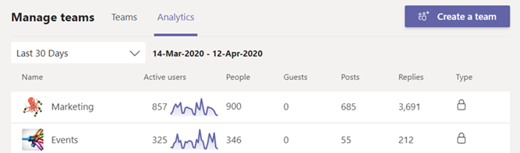

|  |  |
| --- | --- |
| Item | Description |
| **Name** | Name of the team. |
| **Active users** | Number of active users on the team and trend line of team activity during the specified time period. |
| **People** | Total number of people on the team in the specified time period. This includes team owners, team members, and guests. |
| **Guests** | Number of guests on the team during the specified time period. |
| **Posts** | Number of new messages posted in team chat during the specified time period. |
| **Replies** | Number of replies in team chat during the specified time period. |
| **Type** | Whether the team is a private team or public team. |

**View per-team analytics:**

1. In Teams, go to the team that you want, click More options **(...)**, and then click Manage team.
2. Click the Analysis tab.
3. Select a date range to show usage data for the team.

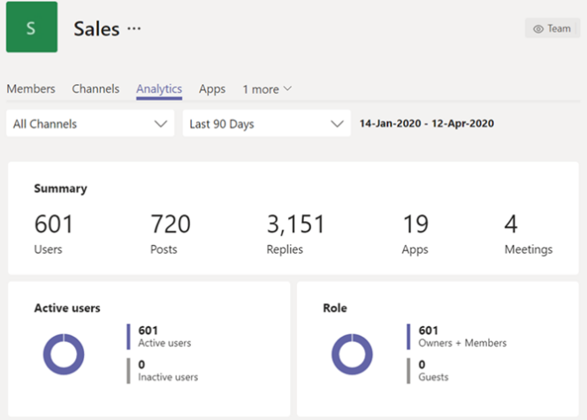

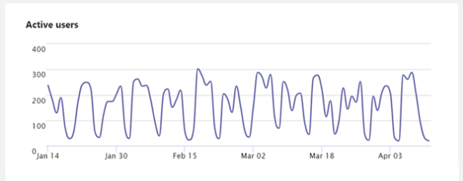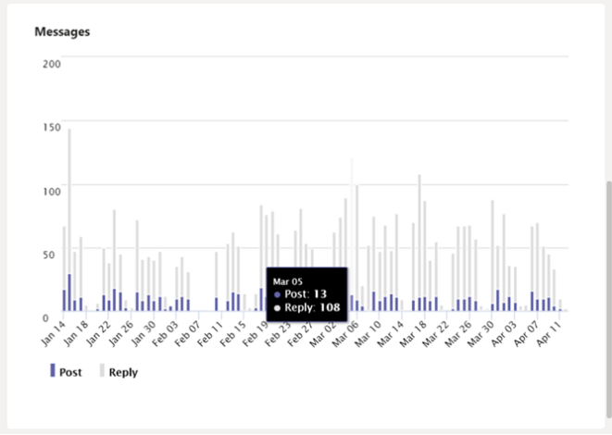

|  |  |
| --- | --- |
| **Active users** | Number of active and inactive users. |
| **Role** | Numbers of users by role, including team owners, team members, and guests. |
| **Active users** chart | Number of daily active. Hover over the dot on a given date to see the number of active users on that date. |
| **Messages** chart | Total number of messages posted in team chat by date. Hover over the dot on a given date to see the number of new posts and replies posted on that date. |